SOCIETY OF BROADCAST ENGINEERS, INC.
The Association for Broadcast and Multimedia Technology Professionals
9102 N. Meridian Street, Suite 150, Indianapolis, IN 46260
317-846-9000

NEWS RELEASE
Contact: Chriss Scherer, Member Communications Director
For Immediate Release cscherer@sbe.org

SBE Publishes Book on TV Master Control Operations
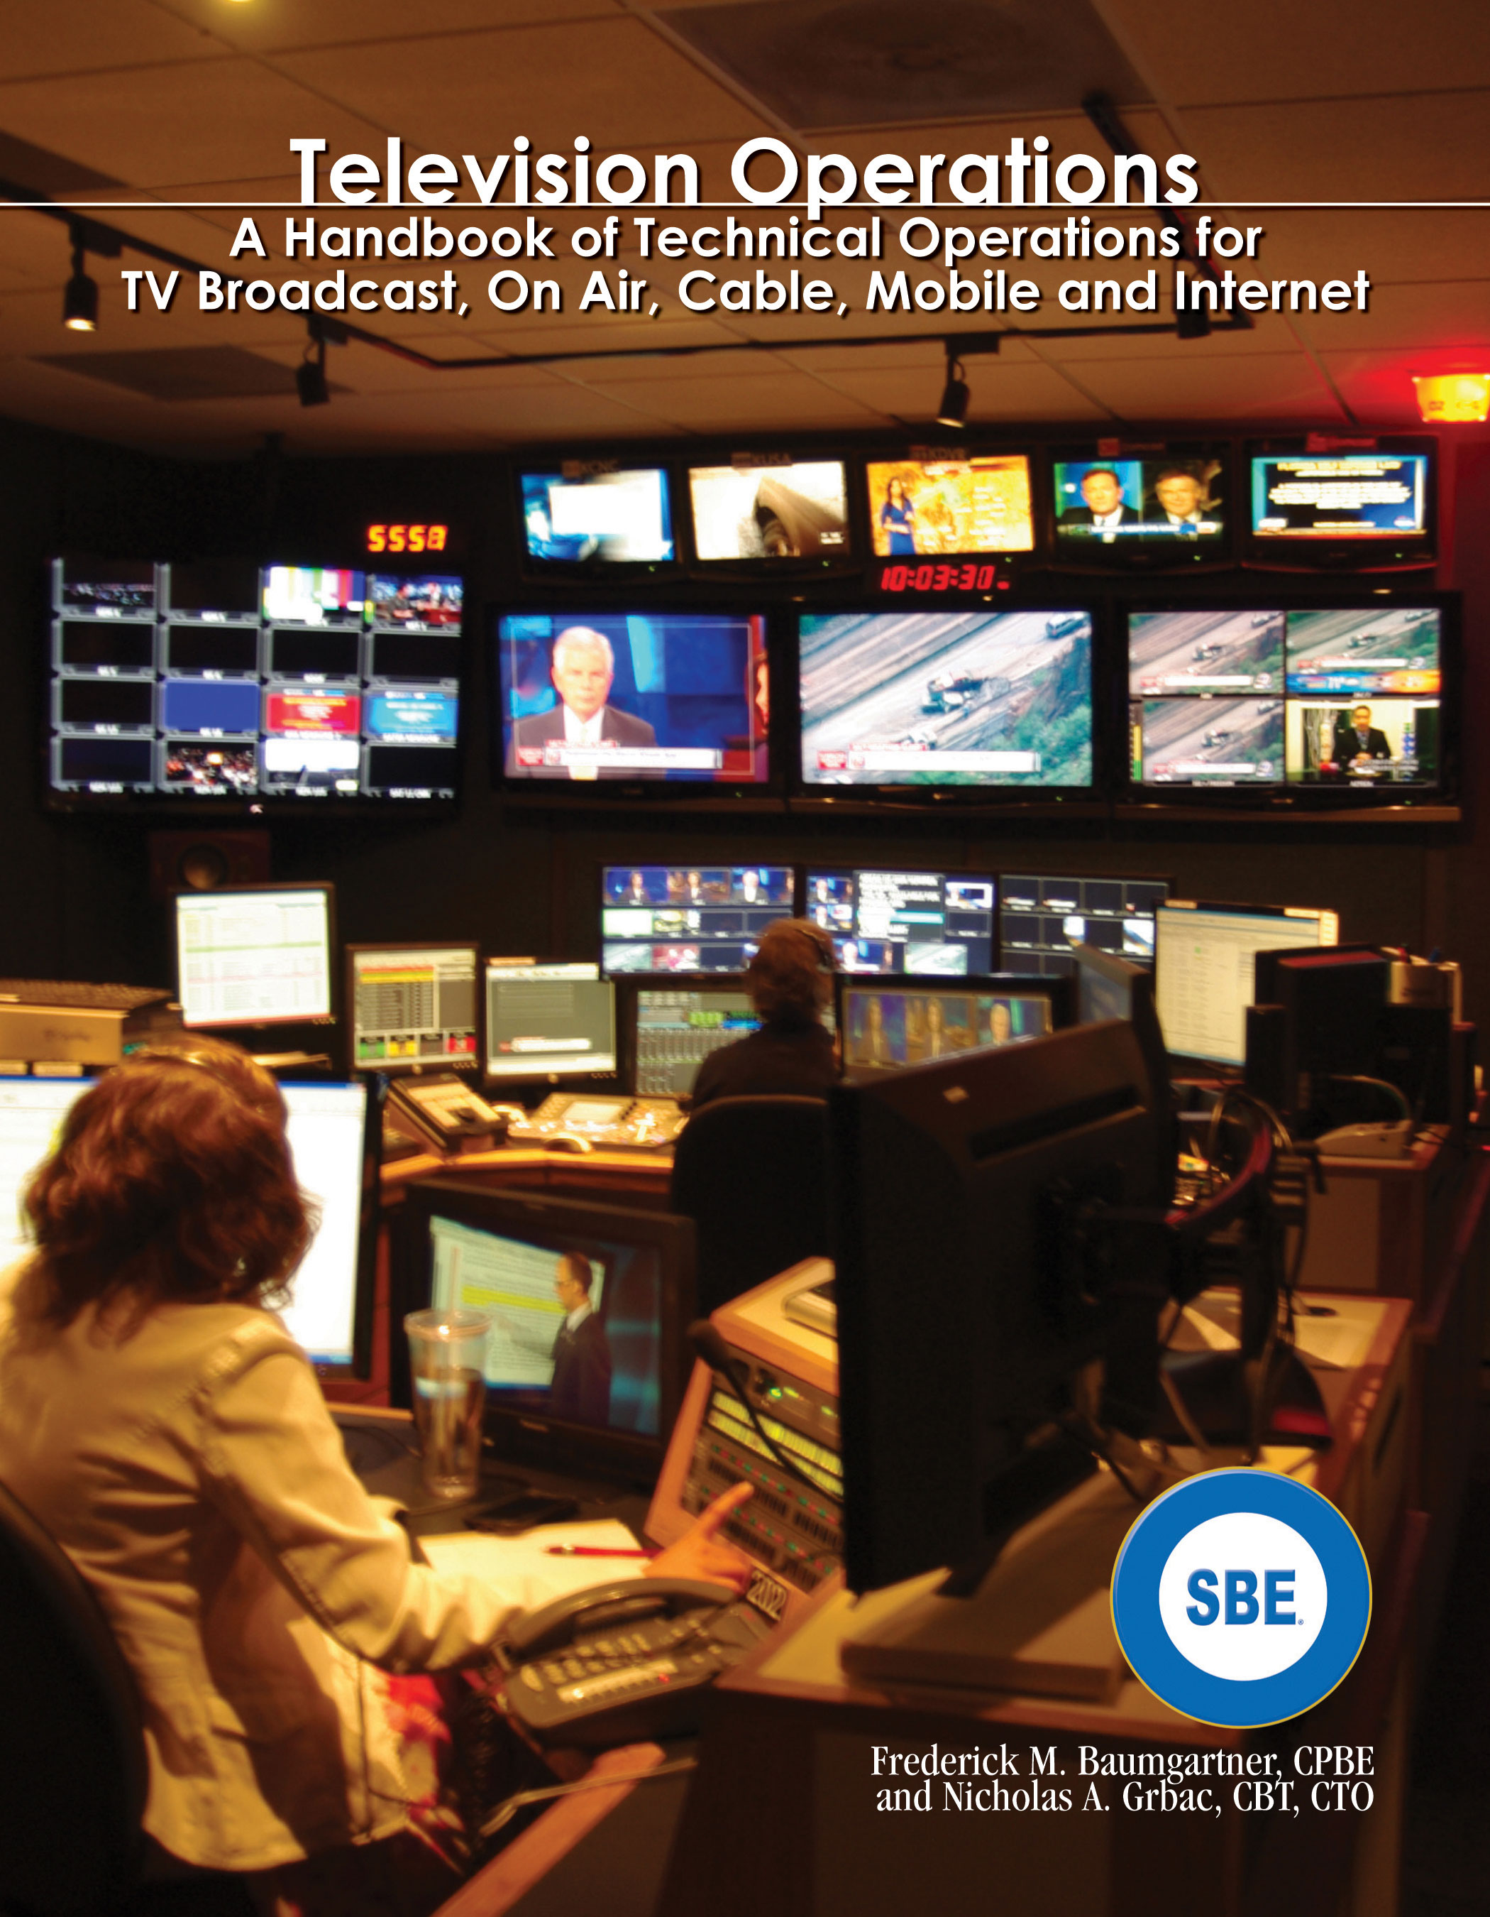
July 29, 2015 - Indianapolis, IN - The Society of Broadcast Engineers, the association for broadcast and multimedia technology professionals, has released its latest publication, Television Operations - A Handbook of Technical Operations for TV Broadcast, On Air, Cable, Mobile and Internet, written by Fred Baumgartner, CPBE, and Nicholas Grbac, CBT, CTO.

The book covers the basics of TV master control operations to familiarize an operator with the concepts, practices and the regulations inherent in the job. The book is specifically designed for those with a minimum to moderate amount of master control exposure. Experienced operators and non-technical managers will also benefit from the text.

SBE President Joe Snelson, CPBE, 8-VSB, said, "The Society of Broadcast Engineers has increased its educational efforts over the past few years. This book is just one of the ways we're providing technical resources to our members and all broadcast and multimedia technology professionals."

The book is available through the SBE Bookstore at sbe.org/bookstore for digital purchase on Amazon.com and BarnesAndNoble.com. A print-on-demand version will be available about August 31.

The Society of Broadcast Engineers is the professional organization of television and radio engineers and those in related fields. The SBE has more than 5,100 members in 114 chapters across the United States and in Hong Kong. There are also members in more than 30 other countries. Most chapters meet monthly and offer educational programs and an opportunity to network with other engineers. The SBE offers the largest and most recognized certification program for broadcast engineers, operators and technicians, with more than 4,500 certifications currently active.

For more information about the SBE, contact John L. Poray, CAE, Executive Director, at jporay@sbe.org or 317-846-9000, or visit the SBE website, www.sbe.org.

Editors: High-resolution image of the book cover:
http://sbe.org/images/hirez/TV_MCO_2015_cover.jpg

